The formation of the Ulster Archaeological Society in 1947

Barrie Hartwell 2017

In order to understand why the Society was founded in 1947, we have to look at the state of archaeology in the interwar years and even earlier by looking briefly at the 'first' and Second Series of the Ulster Journal of Archaeology and putting them in an historical context.

There has long been an interest in archaeology in the province of Ulster - in the 1830s the Ordnance Survey swept through Ireland producing a 6" map survey that located many sites of antiquarian interest and luckily for us, in Ulster, embarked on a parallel written memoir that recorded antiquities such as Dane's Forts, Druidical Altars and Circles and many other sites measured, drawn and described in the nomenclature of the time. Interest in history, arts, literature and the sciences flourished in all sections of society and personal collections of artifacts were established. These were brought together for public attention in an exhibition of Irish Antiquities in Belfast at the Meeting of the British Association for the Advancement of Science in 1852. The exhibition, to quote:

...'excited a very considerable interest; and was visited by large numbers from the most distant parts of the Province...and the taste for such subjects is not confined to one class of the community; but exists in a much lower grade of society than would be anticipated.'

Those are the words of the polyglot and Irish scholar, Robert Shipboy MacAdam. He was one of the organisers of the exhibition which led directly to the publication of the 'first series' of the Ulster Journal of Archaeology under his editorship. Archaeology in the first 1853 volume of the Journal is given a broad antiquarian interpretation, much of it based on literary investigations and largely reflecting MacAdam's wide personal interests.

First volume of the ‘First Series’ of the Ulster Journal of Archaeology
However, the context in which he places archaeology is one that we can recognise today. In the preface he writes:

'Archaeology, the science, par excellence, of "old things" like all other divisions of human knowledge, when rightly viewed, does not stand by itself but is continually coming into contact with other sciences........ It is not history; it is not philology; not ethnology; but these and many other subjects are interwoven with it so closely, that the boundaries can hardly be defined.... Every science may be said to have its archaeological province.....'

Today he is largely remembered for his recording and promotion of the Irish language and traditions but he clearly considered his greatest achievement lay in a slightly different direction, as can be seen from his tombstone.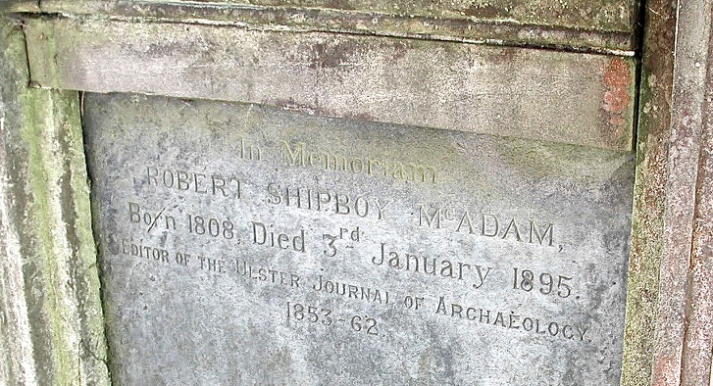
Robert McAdam's tombstone in Knockbreda Parish Church

This first series of the Journal ran from 1853 to 1861. A change in direction saw a move from observation and recording towards a more active intervention in the archaeological landscape and an increasing number of excavations were undertaken by members of the Belfast Naturalists Field Club (BNFC). They produced a catalogue of sites and finds from Ulster for another visit by the British Association for the Advancement of Science in 1874 but these were based on a simplified morphology and the great problem of establishing an effective chronology remained. However, by 1894 there was sufficient head of steam and recognition that, to quote - '...the face of the country is changing, and local sources of information (are) gradually dying out' - to produce a second series of the Ulster Journal of Archaeology, this time edited by the antiquarian, folklorist and promoter of all things Irish - Francis Joseph Bigger.
Francis Joseph Bigger
1863-1926
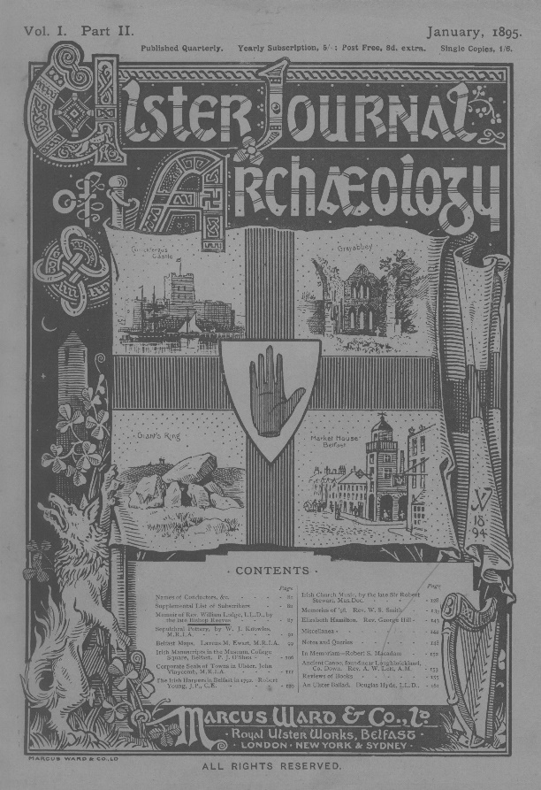
First volume of the 'Second Series' of the Ulster Journal of Archaeology

It ran until 1911 and each year was published in four parts. The coverage was as diverse as the first series, reflecting Bigger's interests, and most of the contributors were drawn from the Field Club (of which he was Secretary, then President) and the Belfast Natural History and Philosophical Society (BNHPS). The Prospectus, published in Volume 1, shows just how wide his remit was:

' The articles will deal with various subjects of interest to the Antiquarian and Student of Local History.... There will be papers on.... pre-Historic Remains, Ecclesiastical Buildings and Records, Castles and Strongholds, Municipal Records and Family Pedigrees....the Danish and Norman Invasions, the Plantation, the wars of 1641 and 1688, and space will be given to the insurrection of '98. Curious and interesting details of the early history of Belfast will be given. The Poetry, Music and Folklore of the North of Ireland will not be forgotten, and space will be given for the preservation of the Irish tongue. Local ballads will be reproduced with explanatory notes of their text and authors...... Any subject helping to elucidate the History or Manners of Ulster will find a place in the Journal.'

Still, the archaeological emphasis, such as it was, remained on individual sites and artefacts. In 1917 Henry Cairnes Lawlor ran an Archaeological section of the BNHPS and published an account of his excavations at the Giant's Ring in Co Down in its Proceedings. In 1928 Lawlor attempted a developmental overview in his publication 'Ulster - its archaeology and antiquities', though it was heavily reliant on documentary sources. Up to this date archaeology had been essentially a community-based interest, introverted in nature - and despite the prodigious achievement of collection, recording, excavation, discussion and publication, the main protagonists were all amateurs with separate day jobs. MacAdam ran a foundry, Bigger was a solicitor, Lawlor worked in the linen industry.

What was missing was an academic rigour and focus and this was eventually provided by courtesy of Queen's University Belfast. As far back as 1910 Queen's had established a post of lecturer in Archaeology and Ancient History in the School of Classics.

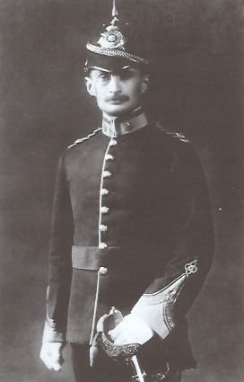
Sir Ian Richmond
1902-1965
Kingdon Tregosse Frost
1877-1914

The first lecturer - KT Frost had excavated and surveyed across the classical world but died in 1914 at the outbreak of war. The position was briefly held by the Roman specialist, Ian Richmond in the late 1920s, at the same time as Queen's appointed Estyn Evans to establish a Geography Department. Evans took a fundamental interest in the landscape of Ulster, was an excellent fieldworker and made a great contribution to Irish folklife studies. He also had a background of excavation in England and was aware of the latest techniques which he was keen to apply. However, there was no official lectureship in Prehistoric Archaeology, even though HC Lawlor was given an honorary MA from Queen's in 1924.
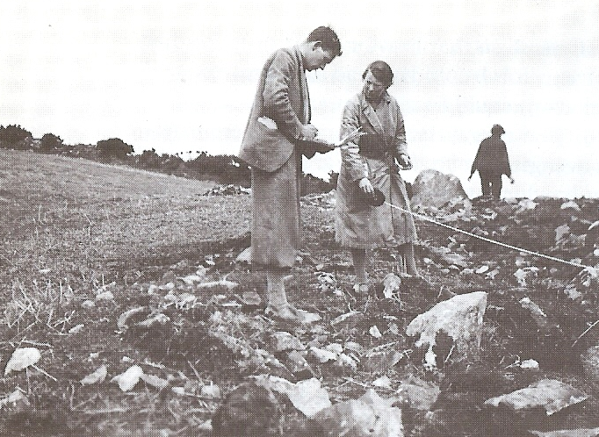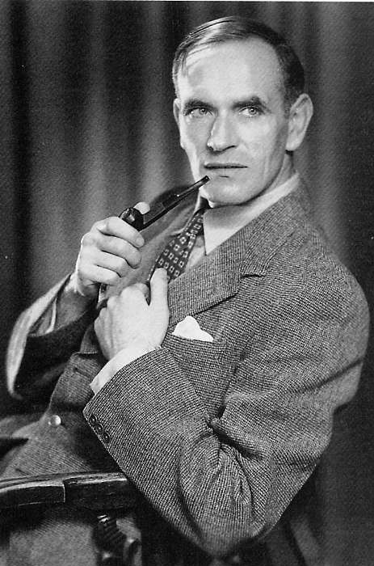
Emyr Estyn Evans in 1935 and 1950

By a happy coincidence, and in parallel to Evans, Oliver Davies was appointed lecturer in Archaeology and Ancient History in 1932. Despite his classical background the eccentric Davies applied himself energetically to the scientific study of all periods of Ulster archaeology. With Evans, and supported by a number of experienced amateurs, he spearheaded a series of excavations on Ulster megaliths to clarify their dating, morphology and origins and contributed to the Preliminary Study of Ancient Monuments of Northern Ireland in 1940.
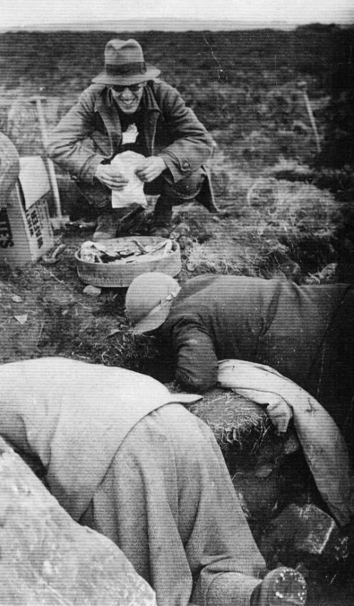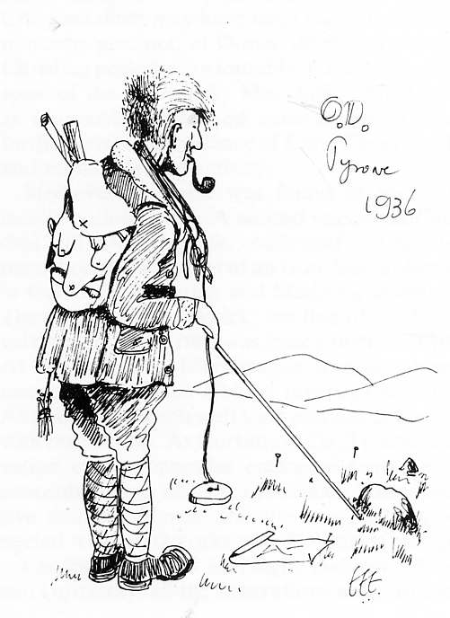
Oliver Davies in 1936

By the 1930's the BNFC Journal and the BNHPS Proceedings were being clogged by excavation reports and many more were outstanding. Davies's queue of prehistoric sites - Dun Ruadh, Clady Halliday, Clontygora, Mourne Park, Inishee and Legland were not finally published in the Proceedings until 1941. The sticking point was that excavations could only continue if there was an adequate method of publication. Oliver Davies later wrote:

'During the last five years nearly a hundred excavations have been carried out in all parts of Ireland, and, of these, proportionately the largest number has been in the Province of Ulster. In 1937 twelve investigations were conducted in Northern Ireland, three of them on sites of first class importance. The first scientific examination of the stone circle at Ballynoe has been commenced by Dr van Giffen of Holland. Mr Evans has begun to excavate the great earthwork and cairn at Lyle's Hill, which is yielding an unrivalled series of Neolithic remains. Mr Davies has found that the settlement of Island McHugh, Baronscourt, provides a stratified record of Irish archaeology from the Neolithic to the seventeenth century...'
Editorial, UJA 3rd series Vol 1, part 1.

A list of excavations, later published in the Ulster Journal of Archaeology, shows 70 were undertaken between 1932 and 1941.

The Minutes survive covering the formation of the Journal and the foundation of the Ulster Archaeology Society and these have been transcribed by Hon. Secretary Ken Pullin. They record that 1937, a conference had been called to develop a scheme of co-operation between the Belfast Natural History and Philosophical Society (founded in 1821 and the grandfather of cultural societies in Ulster) and the Ulster Society for Irish Historical Studies (founded in 1936), for the production of a joint journal devoted to archaeology and history. This clearly did not satisfy the archaeologists and a meeting was called by Estyn Evans, Oliver Davis and five prominent members of the BNFC and BNHPS (Blake Whelan, Davison, Herring, Lawlor and Skillen) in the Greek Department at Queen's on March 3rd 1937 to establish a new journal devoted to archaeology. Negotiations continued with the Irish Historical Studies but on 22nd June 1937, and much to their annoyance, it was decided to abandon these and appeal for public support for a new journal which was to be called the 'Ulster Journal of Archaeology, III series'.

Oliver Davies offered to pay £60 into a trust fund for the journal and £30 per year for five years towards production. This is equivalent to £14000 in today's money and although the offer does not seem to have been accepted, it shows the level of passion and commitment surrounding the establishment of the new publication. It was decided to model the size on the successful British archaeological journal 'Antiquity', then just 10 years old. Three thousand circulars were sent out and by the 9th August the Treasurer reported that 240 subscriptions had been received. The Senate of Queen's University also voted to grant-aid the Journal. At a meeting in the Archaeology Department on 12th October, the typeface, format and the cover design, in dove grey were approved as well as the production of each volume in two parts to be dated January and June. Six hundred copies of part 1 would be printed.
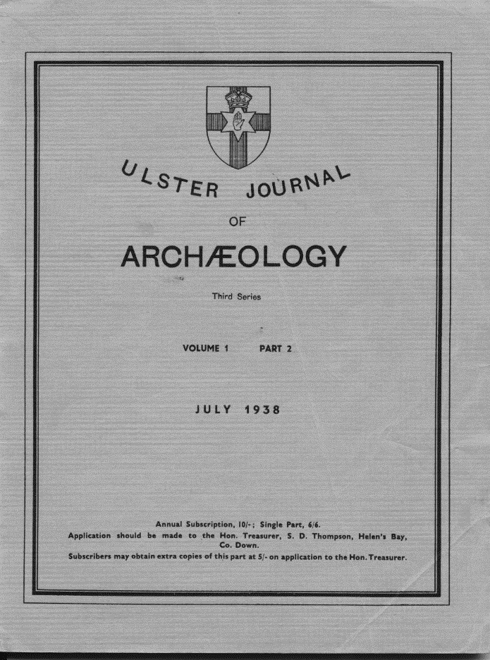
Ulster Journal of Archaeology III Series
Volume 1 appeared in 1938 with Oliver Davis as Editor. Part 1 contained 119 pages covering 22 articles, six notes and two reviews. There were three excavation reports - Ballyedmond and Doey's Cairn by Estyn Evans and Carrick East Cairn by Oliver Davies and J.B. Mullin. The other articles featured site types, individual surveys, artefacts and surnames. Oliver Davies wrote or contributed to seven articles, Estyn Evans 3, HC Lawlor 3, and TGF Patterson, 4. It was almost as though a dam of pent-up knowledge had burst. The war took its toll but a decision was made to continue publishing the Journal, although from 1942 parts 1 and 2 were
published as a single volume.

The composition of the Committee eventually settled down to Rev. Dean Carmody in the chair and in addition to the founding members - Miss Gaffikin, WM Gilmore, SD Thompson, AS Pringle, FJ Cole and Lady Dorothy Lowry-Corry were appointed. After two meetings Oliver Davies again took the Chair on the illness and death of Dean Carmody. Meetings subsequently were chaired in rotation and Oliver Davies became Editor-in-chief. Committees and sub-Committees met when necessary and at least once per year in October for an AGM. From November 1945 most of the minutes record the meeting of the Excavation Committee. The Belfast Municipal Museum and Art Gallery had granted £75 for survey and excavation and this was matched by the Ministry of Health and Local Government. The Ancient Monuments Committee had paid a sum of £250 in lieu of labour grant in former excavations and Davies hoped to utilize this for student labour. The Committee therefore had the sum of £400 to dispense - nearly £16000 in today's money. Then as now, insurance was a problem and it was decided to have a new policy issued under the Workmen’s Compensation Act.

At a meeting of the Excavation Committee on the 15th October 1946 it was first mooted that an archaeological society be formed and a special committee was set up to discuss it. At the AGM on the 13 November it was proposed by Oliver Davies and seconded by Mr Mogey that the Committee forms itself into a society to be known as the 'Ulster Archaeological Society'. The first meeting of the newly formed Society was held on October 15th, 1947 in Queen’s University with Mrs. Dehra Parker in the chair. The Minutes relate that:

'Short lectures with slides were given by A McL. May, O Davies and Prof Evans dealing with excavation work carried out during the summer. Dr Bersu’s contribution was read by Prof Evans. Tea was provided for the members at the Society’s cost.'

In effect the new Society met annually for election of Officers and short presentations and this was billed as the joint Ulster Journal of Archaeology and Ulster Archaeological Society AGM until at least 1950. The last recorded meeting of the Excavation Committee was in November 1951.

Oliver Davies left Queen's in 1948 to take up a post of Professor of Classics in Natal University, Pietermaritzburg in South Africa and the post of Archaeology and Ancient History was split and an independent Department of Archaeology with a wider European remit and special reference to Ireland was established under Martyn Jope.

In 1949 Jope took over as editor of the Journal, offering the fledgling Society a permanent home at Queen's in 17 University Square and from 1986 in the lecture hall of the Elmwood Building. In 1950, the government established the Archaeological Survey, bringing Dudley Waterman and Pat Collins to the Northern Ireland and their long list of excavations and articles published in the Ulster Journal bears witness of their enormous contribution as does that defining publication 'The Archaeological Survey of County Down'.
Professor Martyn Jope, 1915-1996

In the last 70 years archaeology has changed and expanded dramatically in the government, the university and the commercial sectors. It has morphed from an amateur to a professional discipline. One in which 'science' really does mean science. The pioneering role of amateurs who laid the foundations to this discipline by research, survey and excavation has largely changed to that of consumers. Against this trend, the UAS has for several years run a very active survey group which is making a real contribution to our knowledge of archaeology in Ulster.

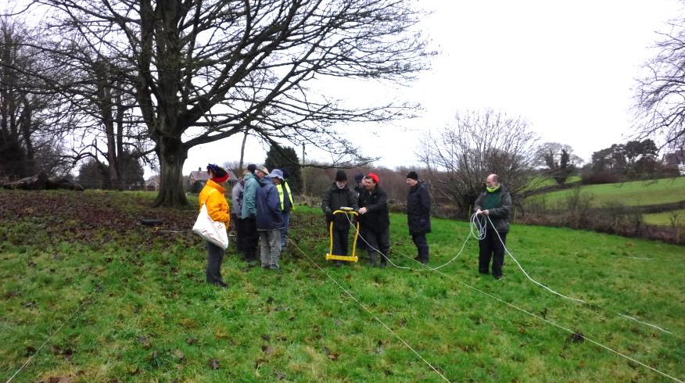

UAS Field Survey Group

The Centre for Archaeological Fieldwork (CAF) at Queen's University involves the local community in many of its projects. Today, it seems as if the wheel has come full circle, as the Archaeology and Palaeoecology Department in the new School of Natural and Built Environment formally reconnects with, and promotes, the public's interest in our heritage by offering courses in Community Archaeology.

Returning to 1947, the visionary work of two Queen's lecturers, Oliver Davies and Estyn Evans have left a legacy of 72 issues of the Ulster Journal of Archaeology and lectures and fieldtrips too numerous to mention. The original subscribers to the Journal became the members and those immutable links between the Journal, the Society and Queens have been maintained for 70 years and are still celebrated today.

Volume 33 (1970) of the Ulster Journal of Archaeology was dedicated to Oliver Davies and Estyn Evans on their retirement and the following year Davies donated £500 to the Society. The then Committee decided to use the sum to institute an occasional 'Oliver Davies Lecture' to be given by a distinguished visitor 'to benefit Queen's students as well as our own full members'. The Journal was to be presented to them at a meeting of the Society on the 25th January 1970. Davies, living in Pietermaritzburg, was about to leave for five weeks fieldwork in the diamond fields of Namaqualand and could not attend. However, he sent a note to be read to the members:

"I would greatly thank the Ulster Archaeological Society for the honour it does to Estyn Evans and myself in dedicating Volume 33 to us. We both realised in the middle of the '30s the need to re-establish the Ulster Journal of Archaeology, though at first it was a struggle to get it going, and the war did not make it easier. This struggle, however, taught a lesson that young archaeologists today would do well to learn, that archaeology must not be allowed to become purely professional, but must accept help and cater to some extent to the interests of the intelligent amateur; if in 1938 we had not realised this, we should have got few subscribers....... The Ulster Journal of Archaeology has for some time been well established as a national journal, worthy to hold its own with Edinburgh, Dublin and many European countries; and I hope it has a long and prosperous life ahead."

